Final project report

Step 1:

Set up AWS environment (IAM, VPC, EC2, RDS, Kinesis, Lambda, S3).

Install and configure PostgreSQL on Amazon RDS.

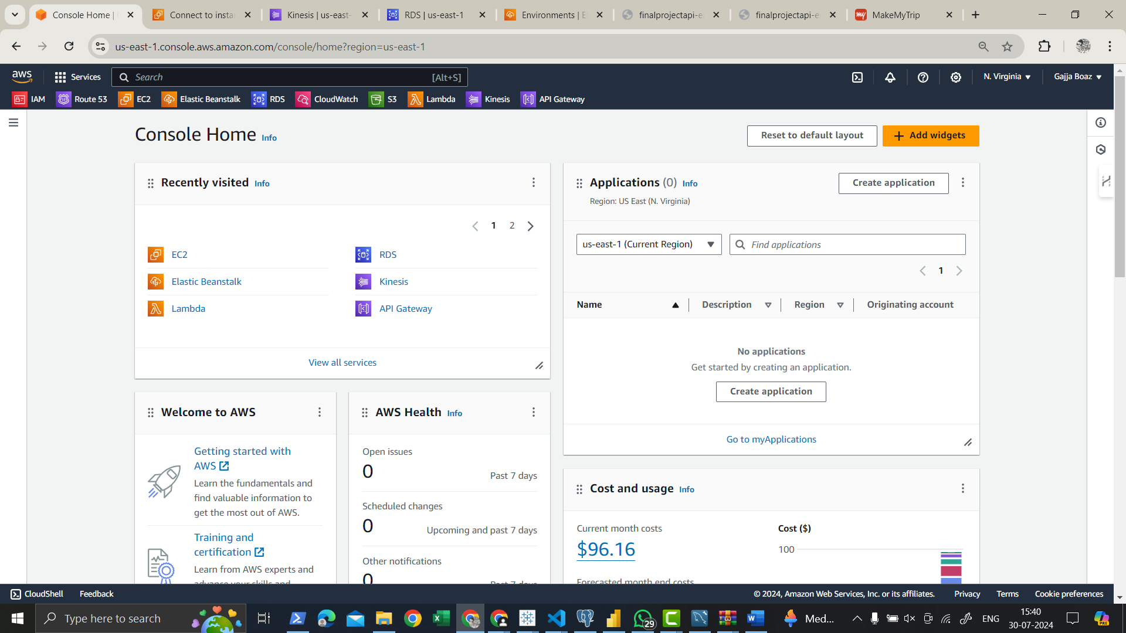

Aws was setup and iam vpc ec2 rds kinesis lambda are created

using this program the data generated is send to the rds

The schema of the table is

Advanced Data Structures and Algorithms:

For api development elastic beanstalk is used

The file is deployed and edited on ec2 instance created

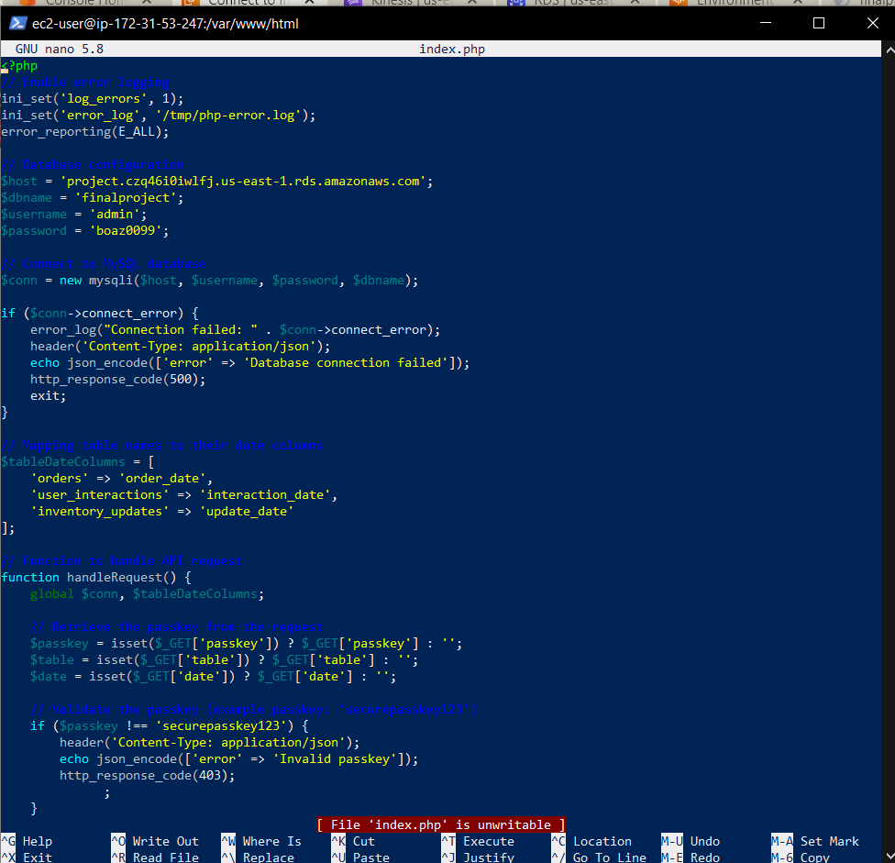

Through the link I sent the passkey for authentication and the table name and the date then on that particular date the data is reviewed

The link used for the above are

<http://finalprojectapi-env.eba-gu35qaty.us-east-1.elasticbeanstalk.com/?passkey=securepasskey123&table=orders&date=2024-07-29>

<http://finalprojectapi-env.eba-gu35qaty.us-east-1.elasticbeanstalk.com/index.php/?passkey=securepasskey123&table=user_interactions&date=2024-07-29>

And the next step is data visualization

Tableau

This dashboard is for orders

sales through the city in Andhra Pradesh

sales through the month

sales through the productid blue color is the above average of the sales and white is below average

product wise inventor updates and inventor changes

Inventor updates monthly

This dashboard is for inventory updates

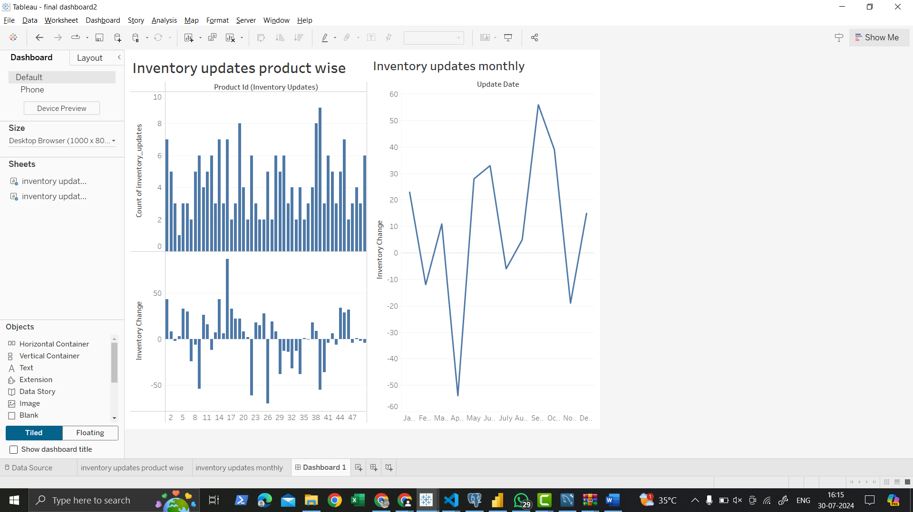

count of interaction type in 2023 and 2024 are increased

count of interaction month wise that means in July there is a sale so many mumbers interacted in july

This dashboard is for interaction

Monitoring the data in kinesis and cloudwatch

Creating the alarm for monitoring

